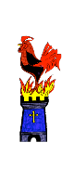
Year 1/2
This week’s learning project focuses on supporting your child with transitioning to their new class. It will give them the opportunity to reflect on their time in their current class, discuss their favourite memories and achievements whilst also considering their hopes and dreams for the next academic year.
Memories | Monday- Over the last year, your child will have created many school memories that they will cherish forever. Capture these memories in a fun way by asking your child to create a ‘Memory Jar’. Using coloured paper ask your child to draw or write down their favourite memories. They can use different colours to show different categories of memory e.g. blue for friendship, yellow for teachers, red for favourite lessons, green for school trips. Use a jam jar or a plastic bottle to collect their memories; they could even personalise their jar with decoration. Share at #kibbyhomelearning
Achievements | Tuesday- Your child has achieved so much over the course of the year and now it is time to reflect on what makes them proud. Ask your child to think about their proudest academic achievements and their proudest achievements outside of the classroom too. After discussing your child’s accomplishments, ask them to choose one. Work together to design and create an achievement medal. Do this by cutting a piece of cardboard into a circle or star shape, painting it gold or sticking shiny paper to it. Write the number one on the medal and add string or ribbon. Why not have a ceremony and present the medal to your child?
Saying farewell | Wednesday- Ending the academic year is a time for your child to say farewell to current teachers and sometimes to classmates too. Talk to your child about the friendships they have made this year. Who is important to them and why? What are they going to miss most about their teacher/teachers? Support your child to draw around their hand on paper and then carefully cut it out. On the template, ask your child to draw or write a goodbye message to a friend or teacher. On each finger, they could write the qualities that this special person has displayed over the year e.g. kindness, being helpful, etc.
Individual qualities | Thursday- Ask your child to think about what makes them special. What makes them different to other people? You could ask other family members to contribute to this too and record a list of your child’s individual qualities together. Following this, ask your child to record their individual qualities on a person template (see below). They may wish to do this by creating a collage using cut out pictures from magazines that represent their individual qualities. Alternatively, they could draw pictures to represent their qualities onto the template. Talk about the importance of being unique together.
Goal setting | Friday- Read or listen to the story ‘Giraffes Can’t Dance’ here. https://safeyoutube.net/w/tUGG  Talk about how Gerald the giraffe showed determination when trying to achieve his goals. Ask your child what they would like to achieve next year, e.g. ‘to improve my handwriting’, ‘count in tens’ or ‘show more kindness to others’. After this, ask your child to choose 5 things from the list which they would like to achieve during their next school year. Work together to create a vision board. This can be done by cutting out pictures that represent the goals, pasting onto card and decorating. They could add personal qualities to their vision board too.

KIbby Home Learning project – to be done throughout the week
Below are some ideas of how your child could set their work out
When you have completed a task you are proud of, send a photo to your teacher or ask a family member to post it on twitter @kibblesworthA
#kibbyhomelearning or #kibbyaroundtheworld
Memories | Achievements | Saying farewell | Individual qualities | Goal setting
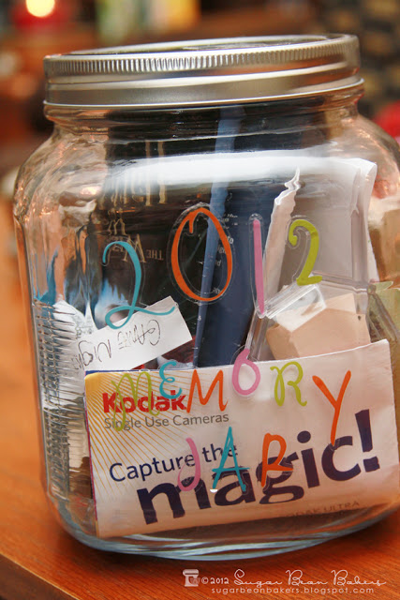 | 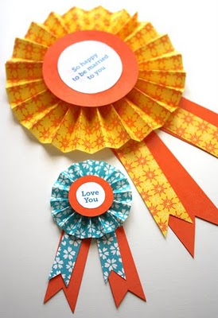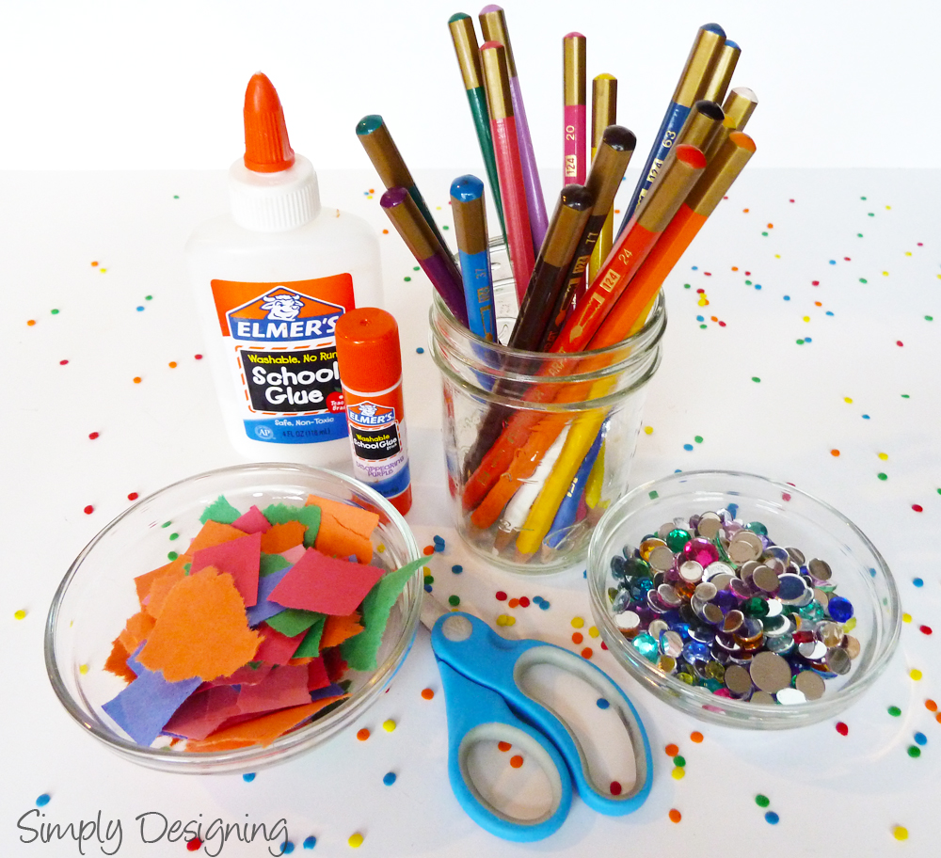 | 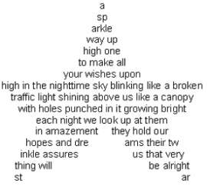 |  | 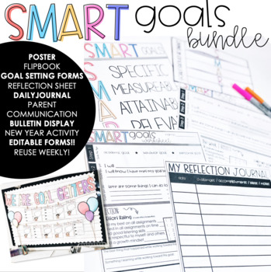
Additional learning resources parents may wish to engage with:
● Tips and resources to support transition from Mentally Healthy Schools can be found at https://www.mentallyhealthyschools.org.uk/risks-and-protective-factors/school-based-risk-factors/transitions/
● The BBC Bitesize website has lots of helpful videos to support transition for both parents/carers and children. https://www.bbc.co.uk/bitesize/collections/starting-primary-school/1
● Parentkind provides handy hints to help prepare your child for their new class.https://www.parentkind.org.uk/Parents/Preparing-your-child-for-school

Please see our school website for other child wellbeing ideas at http://www.kibblesworthacademy.org.uk/website/child_wellbeing/495186

